Salzburg, Austria
March, 2025
COPA-DATA to showcase innovative energy solutions at EM-Power 2025 in Munich
Automation software supplier COPA-DATA will exhibit at EM-Power Europe 2025, the leading international exhibition for energy management and integrated energy solutions. Taking place from May 7–9, 2025 at Messe München, EM-POWER is a key event for stakeholders in the renewable energy sector. From booth B5.356, COPA-DATA will showcase its zenon software platform, an innovative automation tool for hybrid energy systems and substation digitalization.
As the energy industry undergoes rapid transformation, companies are increasingly adopting hybrid infrastructures — combining traditional power generation with renewable energy assets such as solar, wind and battery storage. However, integrating a mix of new and existing assets from various manufacturers presents a challenge. To efficiently manage these evolving fleets, energy operators require centralized solutions. “zenon addresses this need by enabling real-time monitoring, automation and optimization, bridging the gap between legacy infrastructure and modern energy management”, says Stefan Hufnagl, Industry Specialist Energy at COPA-DATA Headquarters.
Under the motto 'Empowering Grids and Prosumers,' EM-Power drives the transformation toward a flexible, digitalized smart grid, seamlessly integrating prosumers, e-mobility, and power-to-heat solutions into a sustainable energy future. From booth B5.356 at the event, the COPA-DATA team will demonstrate zenon's capabilities as an independent software solution for the optimized operation of large-scale renewable energy assets. This includes solar PV, battery energy storage systems (BESS), on- and offshore wind power as well as hybrid microgrids.
Smart software for energy industry
zenon offers an intelligent platform to tackle many of the current challenges of power generation and transmission. At EM-POWER 2025, COPA-DATA will demonstrate how its flexibility helps address workforce and skills shortages by enabling energy automation without the need for extensive software development expertise. What’s more, the team will exhibit how vendor-independent architecture and support for over 300 communication protocols allows for integration of energy assets and ensures efficient data processing and optimization for operators.
zenon also facilitates the transition from conventional to digitalized substations. With long-standing support for IEC 61850, the industry standard for digital substations, zenon enables operators to modernize their infrastructure by integrating conventional substation assets with digital systems.
Upcoming strategic shifts
Economic and legal changes in the energy industry also call for strategic realignment. “To remain competitive and economically viable, companies must continuously modernize their processes and systems, drive the digitalization and automation of core assets and break down information silos that persist in the industry. This foundation is essential for creating efficient, proactive and future-ready businesses,” explains Stefan Hufnagl.
Jürgen Resch, Director Industry Management Energy at COPA-DATA Headquarters, adds: “zenon offers seamless integration across all energy and infrastructure processes and assets at every level of the grid. Its design philosophy ensures that standalone solutions can be effortlessly combined into a unified management system, requiring minimal effort while delivering invaluable synergies for users.”
"The transition to renewable energy comes with unique challenges, and zenon empowers the energy sector by optimizing energy production and distribution. As the industry moves toward a cleaner, more sustainable future, automation plays a crucial role in integrating Distributed Energy Resources like solar, wind, and battery storage. Our technology not only keeps pace with this transformation but actively drives it forward,” says Lewis Williams, Industry Specialist Energy at COPA-DATA.
Connect with leading industry experts
Attendees of EM-Power 2025 are invited to visit COPA-DATA at booth B5.356 for live demonstrations of zenon in energy automation. Its industry experts Jürgen Resch, Stefan Hufnagl, Lewis Williams and Wolfgang Spirek will also be available for in-depth consultations on managing hybrid energy infrastructures with zenon.
For more information on COPA-DATA’s software to navigate current industry challenges, visit the website to explore its automation solutions for the energy sector. Learn more about how zenon can support solar PV and wind power operations. If you’d like to attend EM-Power 2025, register here. COPA-DATA is offering a number of free daily tickets to the event – contact us at events@copadata.com to secure your ticket.
About COPA-DATA
COPA-DATA is an independent software manufacturer that specializes in digitalization for the manufacturing industry and energy sector. Its zenon® software platform enables users worldwide to automate, manage, monitor, integrate and optimize machines, equipment, buildings and power grids. COPA-DATA combines decades of experience in automation with the potential of digital transformation and a strong drive for sustainability-enabling solutions. In this way, the company supports its customers to achieve their objectives more easily, faster and more efficiently.
The family-owned business was founded by Thomas Punzenberger in 1987 in Salzburg, Austria. In 2024, with more than 450 employees worldwide, it generated revenue of EUR 99 million. The property rights of Ing. Punzenberger COPA-DATA GmbH were transferred to a family foundation in 2024. The purpose of the foundation is the long-term and growth-oriented preservation of the profitability and innovative corporate culture of the software company.

Images
Image 1: Industry Management Energy & Infrastructure at COPA-DATA Headquarters
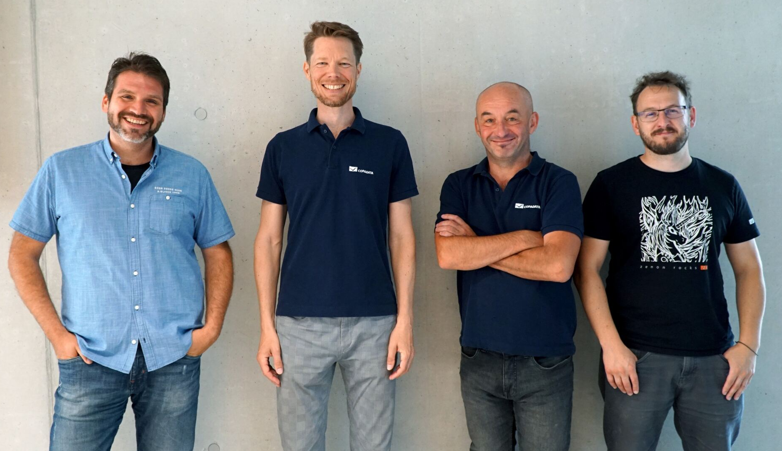
(from left) Stefan Hufnagl, Industry Specialist Energy, Jürgen Resch, Director Industry Management Energy, Wolfgang Spirek, Industry Specialist Energy and Lewis Williams, Industry Specialist Energy.

Image 2: Stefan Hufnagl, Industry Specialist Energy at COPA-DATA Headquarters

“To remain competitive and economically viable, companies must continuously modernize their processes and systems, drive the digitalization and automation of core assets and break down information silos that persist in the industry. This foundation is essential for creating efficient, proactive and future-ready businesses,” explains Stefan Hufnagl, Industry Specialist Energy at COPA-DATA Headquarters.

Image 3: Jürgen Resch, Director Industry Management Energy at COPA-DATA Headquarters

“zenon offers seamless integration across all energy and infrastructure processes and assets at every level of the grid. Its design philosophy ensures that standalone solutions can be effortlessly combined into a unified management system, requiring minimal effort while delivering invaluable synergies for users”, says Jürgen Resch, Director Industry Management Energy at COPA-DATA Headquarters.
Image 4: Lewis Williams, Industry Specialist Energy at COPA-DATA Headquarters

“As the energy industry moves toward a cleaner, more sustainable future, automation plays a crucial role in integrating Distributed Energy Resources like solar, wind, and battery storage. Our technology not only keeps pace with this transformation but actively drives it forward,” says Lewis Williams, Industry Specialist Energy at COPA-DATA Headquarters.

Image 5: Energy Landscape zenon Software Platform
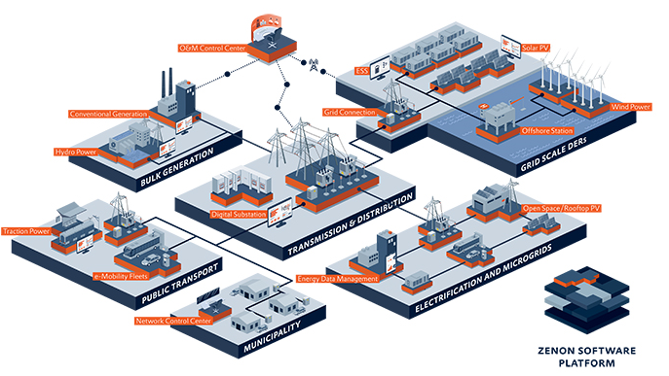

Press contact COPA-DATA Headquarters
Samuel Inwinkl
Public Relations Consultant
T: +43 662 431002-243
samuel.inwinkl@copadata.com
Ing. Punzenberger COPA-DATA GmbH
(COPA-DATA Headquarters)
Karolingerstrasse 7b
5020 Salzburg
press@copadata.com
www.copadata.com

Press contact Stone Junction
Laura Swire
Account director
Stone Junction Ltd
Water Street, Suites 1&2, The Malthouse
Stafford, Staffordshire, ST16 1AR
T: +44 (0) 1785 225416
press@copadata.co.uk
www.stonejunction.co.uk

