Salzburg, 30. January 2025
COPA-DATA continues on course of double-digit growth
From 87 million euros in 2023 to 99 million euros in 2024: the Austria-based software manufacturer COPA-DATA achieved turnover growth of 14 percent in 2024 as its consistently positive development continues. The number of employees is also growing dynamically: at the end of 2024, the family business employed 450 people worldwide – up from 400 a year earlier.
Anti-cyclical investments, a focus on growth-orientated sectors, strategic job expansion, targeted personnel development and a high level of customer satisfaction are some of the many reasons for COPA-DATA's growth. The software manufacturer is represented at 29 locations worldwide. From those, it supports customers locally with qualified sales and service personnel. “Last year’s success shows us that we are on the right track. We sincereley thank our customers for their trust,” says Phillip Werr, Member of the Executive Board. “The team deserves great recognition; their passion, commitment and sound expertise are the key drivers of our success.”
New subsidiary in Japan
The company’s success is also reflected in the growth of the global team. Stefan Reuther, Member of the Executive Board comments: ”Over the years, we have established ourselves as a reliable and attractive employer. We are actively counteracting the shortage of skilled labor and are able to recruit employees all over the world.” This can be seen in Japan, for example. COPA-DATA founded a subsidiary in Tokyo in 2024. “The location fits with our growth strategy. We are moving closer to our customers in one of the world's largest economies,” emphasizes Stefan Reuther. Further investments in Austria and internationally are planned for 2025.
Participation in the World Economic Forum
In addition to participating in over 50 trade fairs through the year, COPA-DATA was part of the World Economic Forum (WEF) meeting in Davos, Switzerland, at the beginning of the 2024. Since then, the software manufacturer has taken part in other international WEF events as an Associate Partner. COPA-DATA contributes as an innovation leader, working at multiple levels with global players from the manufacturing and energy sectors. Core focus areas include sustainability and digitalization, including as part of WEF’s Industry Net Zero Accelerator initiative. Because the zenon software platform helps to make production more resource-efficient and energy-efficient, COPA-DATA’s perspective makes a valuable contribution. The company’s collaboration with WEF continues through 2025.
Shaping megatrends
zenon offers solutions for the megatrends of digitalization, automation and sustainability. The zenon software platform spans disciplines, both technologically and across locations. As such, COPA-DATA is a pioneer of ”modular production” by helping to make processes more flexible and efficient, especially in the manufacture of medicines. zenon also has a global presence in the energy industry and supports the modernization and expansion of electrical grids. In this way, it supports the energy transition toward renewable energies.
Safeguarding independence
In 2024, the Punzenberger family established a family foundation and transferred ownership of the group of companies to it. “This is how we will secure the long-term independence and future of the company,” explained founder and Chief Executive Officer, Thomas Punzenberger, the decision to take this step. His sons Felix and Lukas are now also contributing to the company as managers of technical teams.
Photos
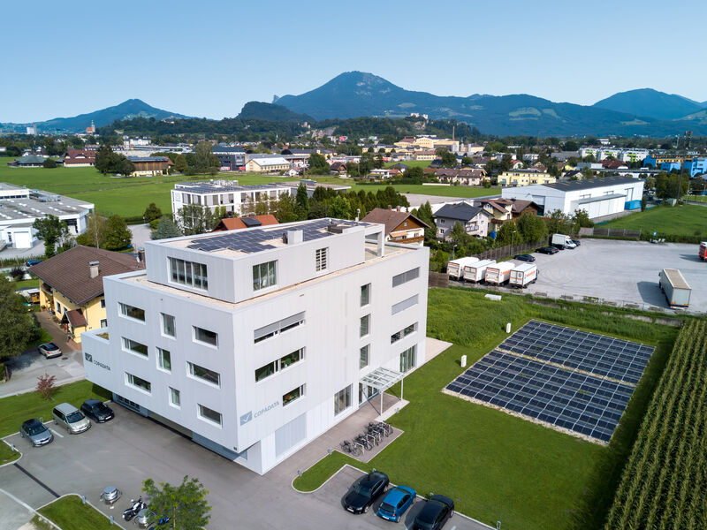
Picture credit: COPA-DATA

Software manufacturer COPA-DATA achieved a turnover of 99 million euros in 2024. Its headquarters are located in the city of Salzburg, Austria.
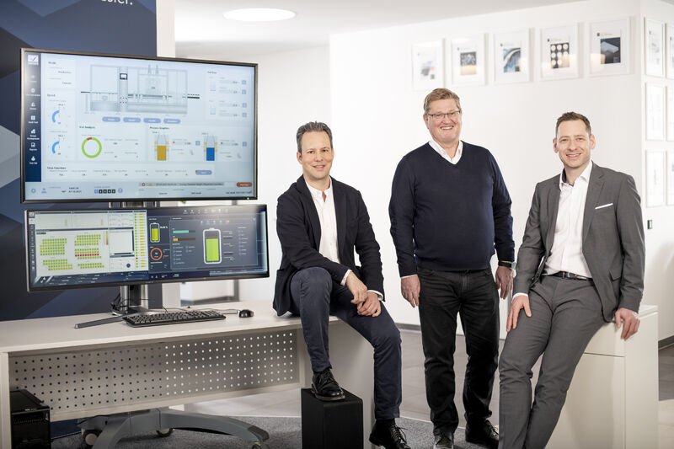
Picture credit: COPA-DATA / Florian Mitterer
Managing the fortunes of the family business (from left to right): Phillip Werr (Member of the Management Board, CMO and COO), Thomas Punzenberger (CEO), Stefan Reuther (Member of the Management Board, CSO)

About COPA-DATA
COPA-DATA is an independent software manufacturer that specializes in digitalization for the manufacturing industry and energy sector. Its zenon software platform enables users worldwide to automate, manage, monitor, integrate and optimize machines, equipment, buildings and power grids. COPA-DATA combines decades of experience in automation with the potential of digital transformation and a strong drive for solutions that achieve greater sustainability. In this way, the company supports its customers to achieve their objectives more easily, faster and more efficiently. The family-owned business was founded by Thomas Punzenberger in 1987 in Salzburg, Austria. In 2024, with 450 employees worldwide, it generated turnover of 99 million euros.

Your contact persons

Michaela Hasslacher
Public Relations Manager
T: +43 662 431002-242
michaela.hasslacher@copadata.com

Sebastian Bäsken
Team Lead Communication & Brand
T: +43 662 431002-345
sebastian.baesken@copadata.com

Ing. Punzenberger COPA-DATA GmbH
(COPA-DATA Headquarters)
Karolingerstrasse 7b
5020 Salzburg
www.copadata.com




